iOS: POP Manual Configuration
This article will assist you with setting up an Apple iOS mobile device, using POP, for your Hosted Mailbox.
- From your iOS device, tap the "Settings" icon.
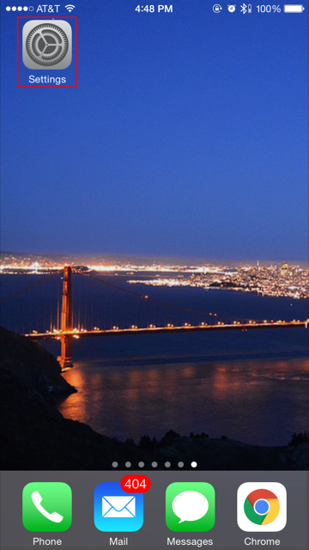
- Tap "Mail, Contacts, Calendars".
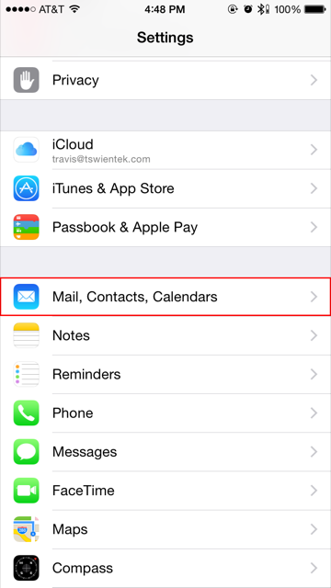
- Tap "Add Account".
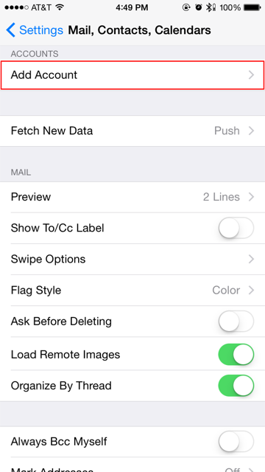
- Tap "Other".
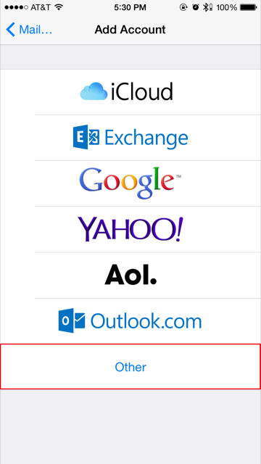
- Tap "Add Mail Account".
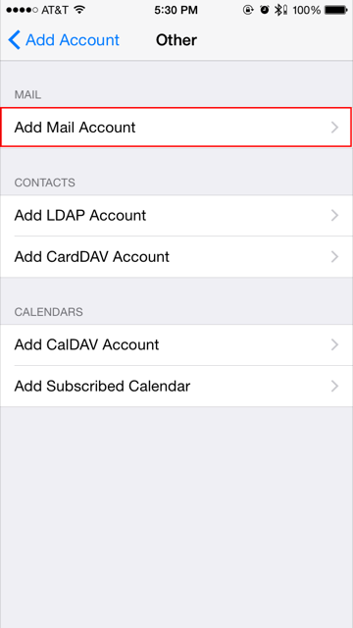
- Ensure "POP" is selected, then enter the following information:
  - "Name": Your first and last name.
  - "Email": ----------------------
  - "Description": Anything you'd like!
  - INCOMING MAIL SERVER:
    - "Hostname": secure.emailsrvr.com
    - "User Name": Your email address
    - "Password": Your mailbox password
  - OUTGOING MAIL SERVER:
    - "Hostname": secure.emailsrvr.com
    - "User Name": Your email address
    - "Password": Your mailbox password
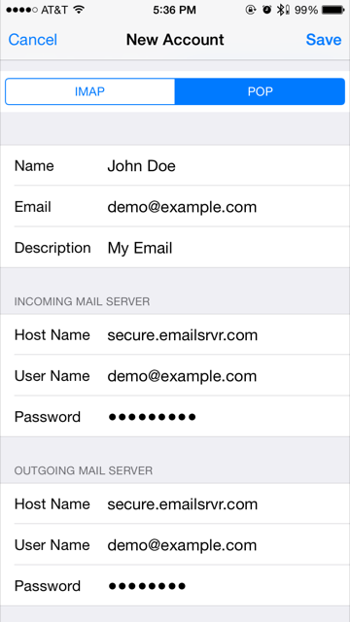
- Tap "Save".
- Now you're done! Launch the Mail app. Your email should appear within a few minutes, depending on the amount of items to sync.

