iOS: IMAP Manual Configuration
This article will assist you with setting up an Apple iOS mobile device, using IMAP, for your Hosted Mailbox.
- From your iOS device, tap the "Settings" icon.
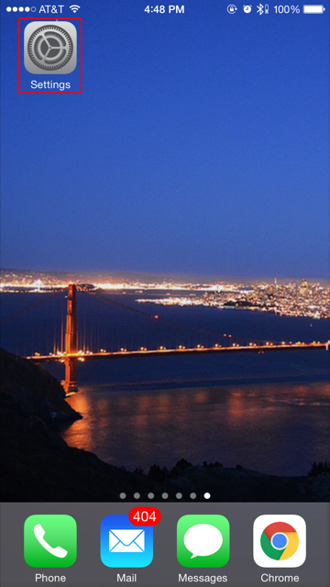
- Tap "Mail, Contacts, Calendars".
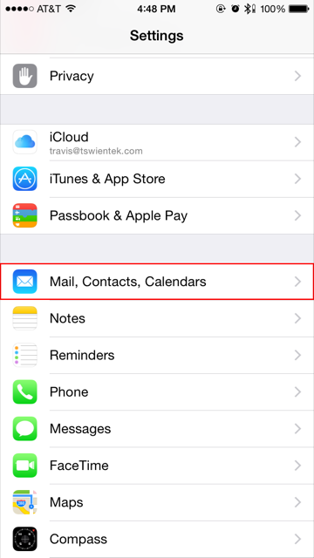
- Tap "Add Account".
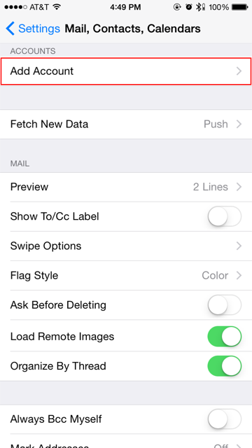
- Tap "Other".
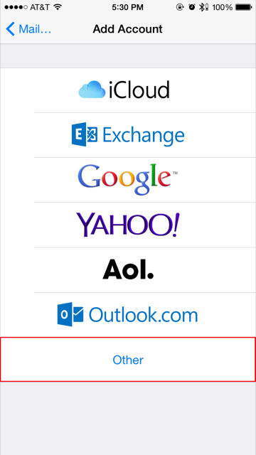
- Tap "Add Mail Account".
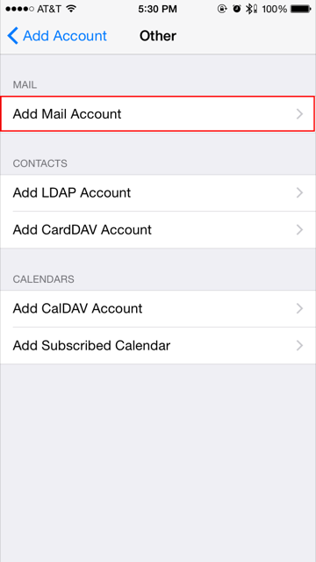
- Ensure "IMAP" is selected, then enter the following information:
  - "Name": Your first and last name.
  - "Email": -----------------------------
  - "Description": PACTEC Email
  - INCOMING MAIL SERVER:
    - "Hostname": secure.emailsrvr.com
    - "User Name": Your email address
    - "Password": Your mailbox password
  - OUTGOING MAIL SERVER:
    - "Hostname": secure.emailsrvr.com
    - "User Name": Your email address
    - "Password": Your mailbox password
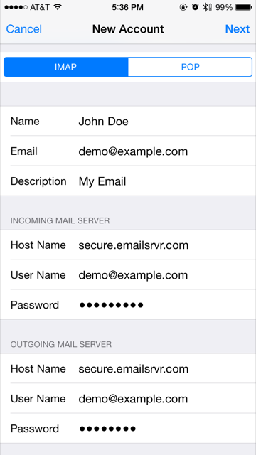
- Tap "Next".
- In the next screen, select the items you wish to sync.
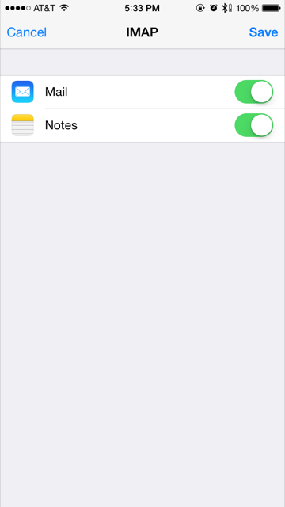
- Tap "Save".
- Now you're done! Launch the Mail app. Your email should appear within a few minutes, depending on the amount of items to sync.
We highly recommend configuring your iPhone to sync your various IMAP folders. Below are the steps to do so.
- Within the "Mail, Contacts, Calendars" settings window, select the account that you just added.
- Under "IMAP", select your Account.
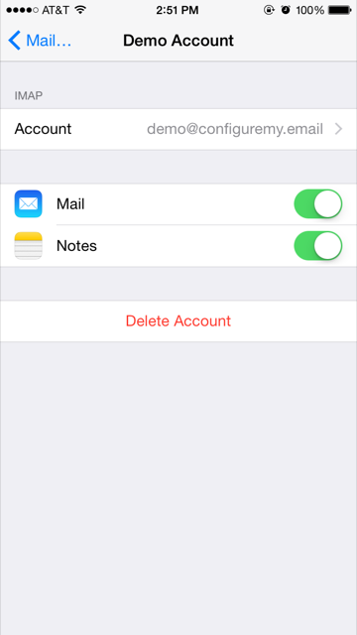
- Within the accounts settings, select "Advanced":
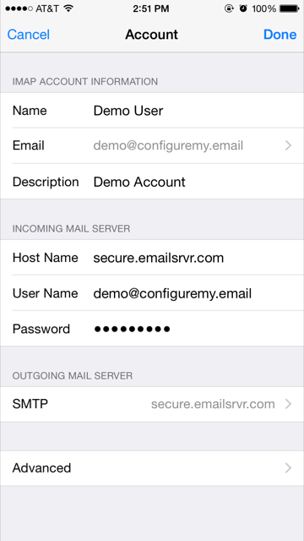
- You should now be at the screen below:
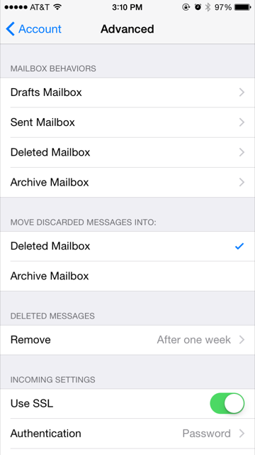
- Under "MAILBOX BEHAVIORS", select the first item ("Drafts"), then select the appropriate folder under "ON THE SERVER". Here's an example for the Drafts folder:
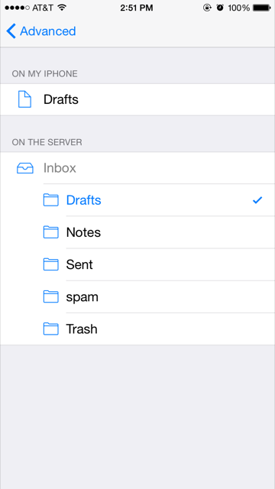
- Now repeat this step for "Sent Mailbox" and "Deleted Mailbox". Ignore the "Archive Mailbox", it won't be used.
- Last step! Make sure "Deleted Mailbox" is selected under "MOVE DISCARDED MESSAGES INTO". This will ensure deleted messages go to the Deleted Mailbox folder.
- That's it! You should be all set now! Enjoy your email.

