## Windows Mobile: IMAP Configuration

This article will assist you with setting up your Windows Mobile or Tablet device, using IMAP, for your Hosted Mailbox.

1. Tap the Windows button and locate the "**Settings**" option from the Application Menu.

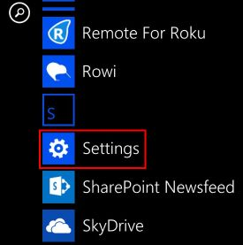

1. Tap "**email+accounts**".

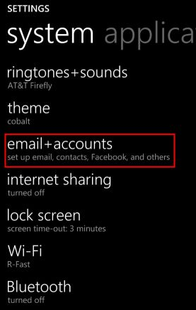

1. Tap "**add an account**".

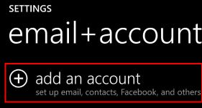

1. Tap "**other account (POP and IMAP)**".

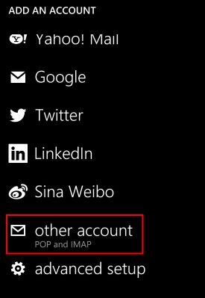

1. Enter the following details:
   1. "**Email Address**": -------------------
   2. "**Password**": Your mailbox password

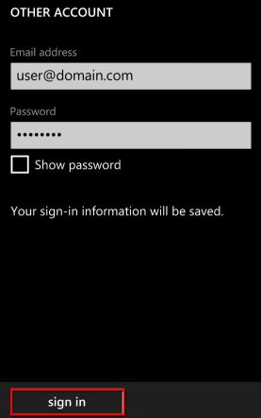

1. Tap "**sign in**".
2. The phone likely will be unable to determine your settings. Tap "**advanced**".

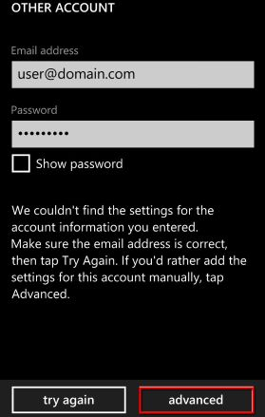

1. Enter the following details:
   1. "**Incoming email server**": secure.emailsrvr.com
   2. "**Account type**": IMAP4
   3. "**Username**": Your email address
   4. "**Password**": Your mailbox password
   5. "**Outgoing (SMTP) email server**": secure.emailsrvr.com
   6. "**Outgoing server requires authentication**": Checked
   7. "**Use the same user name and password for sending email**": Checked
2. Tap "**sign in**".
3. Now you're done! Your mailbox should begin syncing within a few minutes.