OSX: Outlook 2011 (POP)
This article will assist you with setting up Outlook 2011, using POP, for your Hosted Mailbox.
- Launch Outlook, if it's not already open.
- From the upper menu, select "Outlook" -> "Preferences".
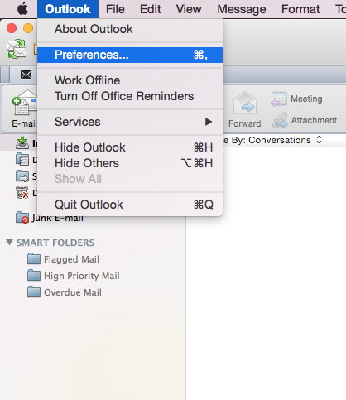
- In the next prompt, select "Accounts".
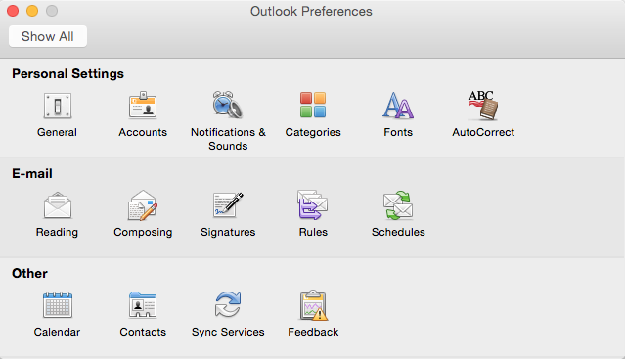
- Within the Accounts dialog, select "Other Email".
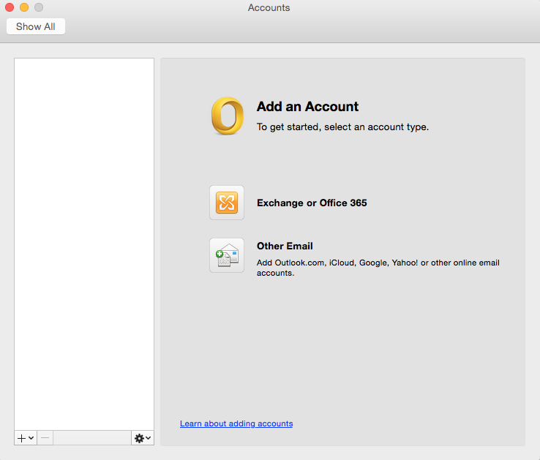
- The pop up dialog will require the following:
  - "Email Address": -----------------------
  - "Password": Enter your mailbox password.
  - "User name": Your email address
  - "Type": POP
  - "Incoming Server": secure.emailsrvr.com
  - "Override default port": Checked
  - "Use SSL to connect (recommended)": Checked
  - "Incoming Server Port": 995
  - "Outgoing Server": secure.emailsrvr.com
  - "Override default port": Checked
  - "Use SSL to connect (recommended)": Checked
  - "Outgoing Server Port": 465
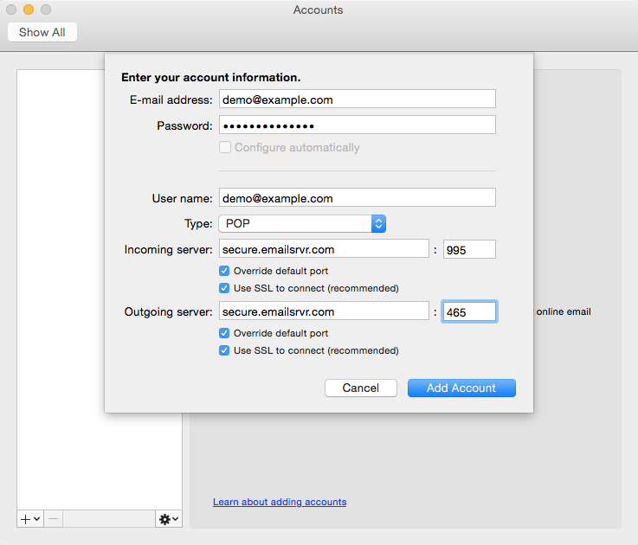
- Select "Add Account".
- Within the Accounts dialog. Select "More Options..." under the "Outgoing server" section.
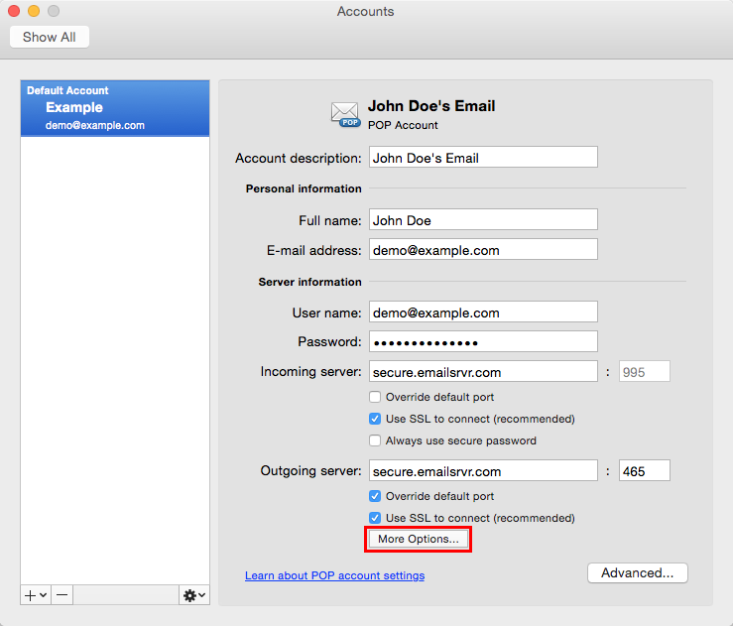
- Within the dialog, ensure the following:
  - "Authentication": Use Incoming Server Info
  - "Unqualified Domain": Leave Blank
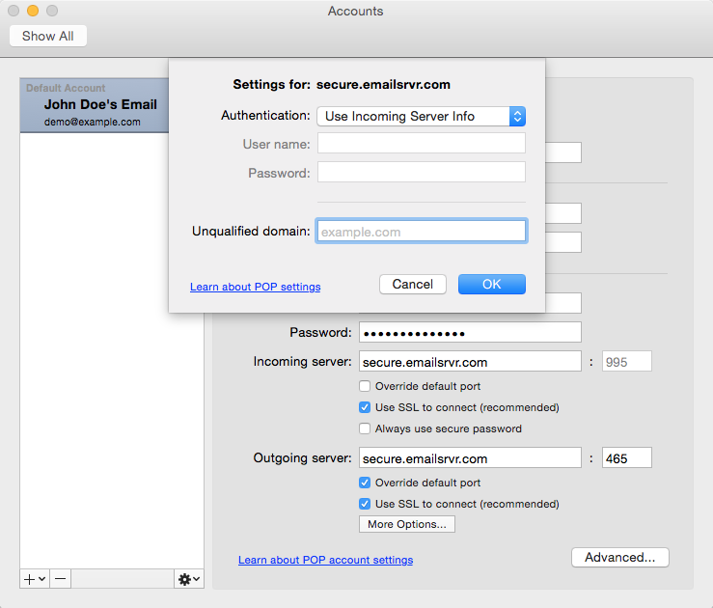
- Click "OK".
- Close the Accounts window.
- Click "Send/Receive". Your email should begin syncing with the server.

