Windows: Outlook 2007 (POP)
This article will assist you with setting up Outlook 2007, using POP, with your Hosted Mailbox.
- Windows 7: Start Menu -> Search. (Search for "Mail")
Windows 8: Open the "Charms" by moving your mouse to the top right of your screen. Select Search. (Search for "Mail")
- On the left side of the screen click on "Mail". Click on "Show Profiles" Then Click on "Add".
- The Profile Name can be anything you would like. Click "OK" and select "Manually configure server settings or additional server types". Click "Next".
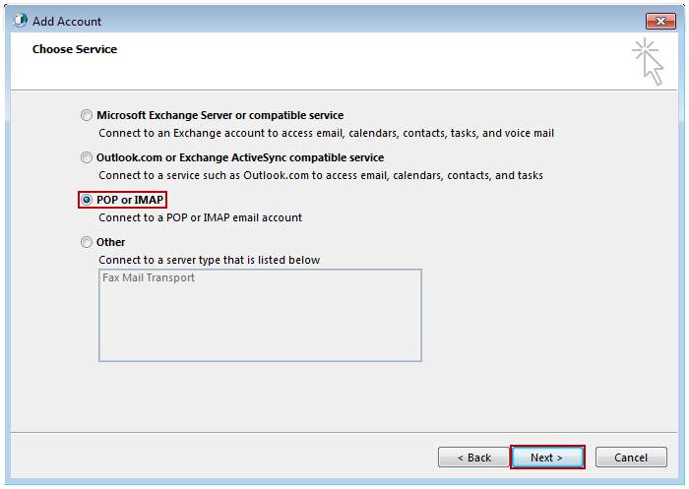
- In the "Add New Account" window, input the following information:
  - "Your Name": The name email recipients will see in the "From" field.
  - "Email Address": ------------------
  - "Account Type": POP
    - "Incoming mail server": (We recommend secure.emailsrvr.com)
Server | SSL | Port
secure.emailsrvr.com | Yes | 995
pop.emailsrvr.com | No | 110
    - "Outgoing mail server (SMTP)": (We recommend secure.emailsrvr.com)
Server | SSL | Port
secure.emailsrvr.com | Yes | 465
smtp.emailsrvr.com | No | 25, 2525, 587, 8025
  - "Logon Information":
    - "Username": Your email address
    - "Password": Your mailbox password
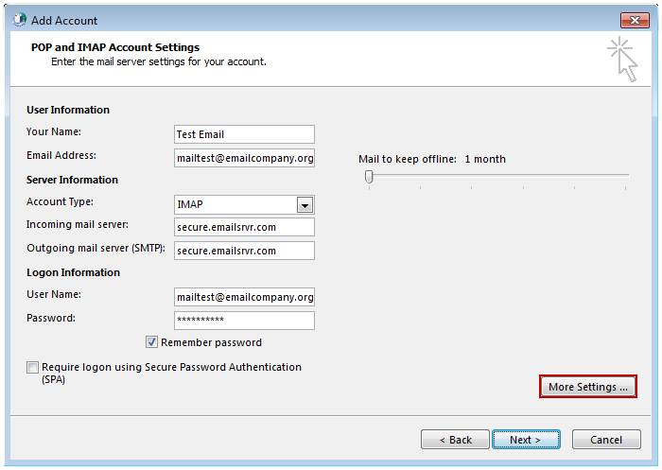
- Click on "More Settings" then click the "Outgoing Server" Tab
  - Check the box for "My outgoing server (SMTP) requires authentication".
  - Check the button for "Use same settings as my incoming mail server".
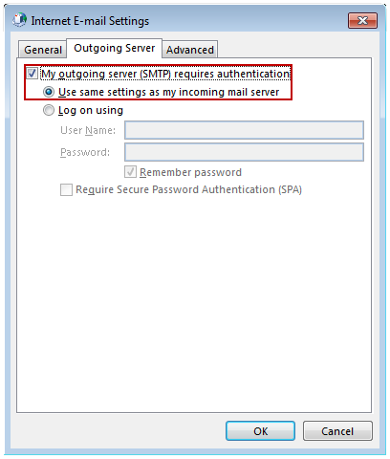
- If using "secure.emailsrvr.com": Click on the "Advanced" Tab
  - Change "Use the following type of encrypted connection" to "SSL".
  - Change the port numbers to match the chart on step 4.c. Click "OK".
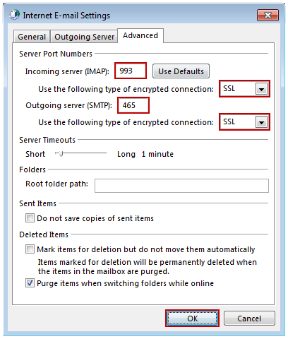
- Click "Next". Outlook will now attempt to send a test message using the settings we have just put in. If everything was entered correctly, the message will send out successfully.
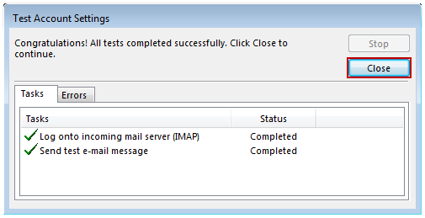
- Congratulations! You have now setup Outlook to work with your Mailbox!

