OSX: Apple Mail (POP)
This article will assist you with setting up Apple Mail, using POP, for your Hosted Mailbox.
- Launch System Preferences. You can easily get to System Preferences by pressing "Command (⌘) + Space Bar". Then type "System Preferences" in the Spotlight search. Press enter to launch the System Preferences application.
- Within System Preferences, click "Internet Accounts". Then, on the right, scroll down and select "Add Other Account...".
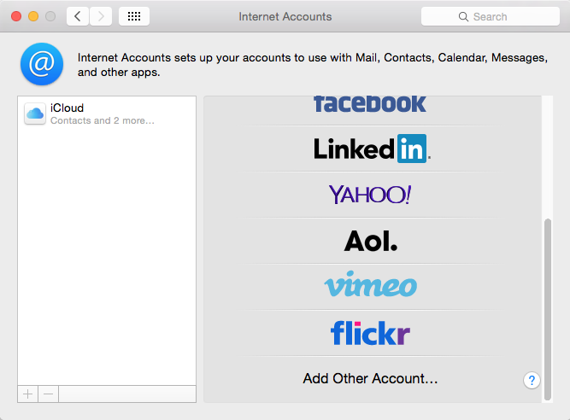
- In the next prompt, select "Add a Mail account". Then click "Create...".
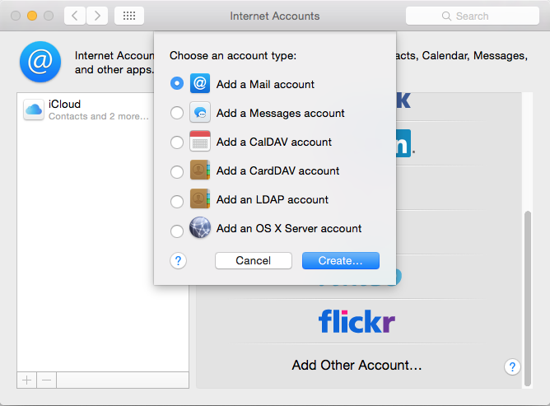
- The pop up dialog will require the following:
  - "Name": Enter your first and last name.
  - "Email Address": ----------------------
  - "Password": Enter your mailbox password.
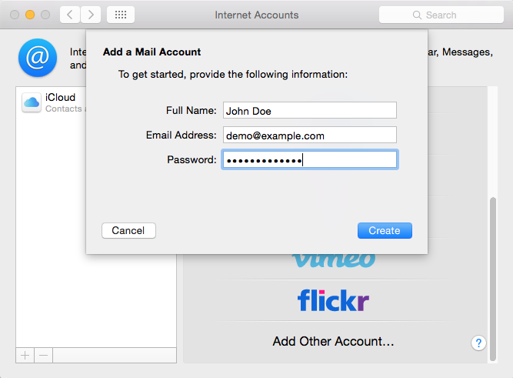
- Select "Create".
- You'll see an alert which says "Account must be manually configured.". Click "Next" once more.
- In the next window, ensure the following:
  - "Account Type": POP
  - "Mail Server": secure.emailsrvr.com
  - "User Name": Your email address
  - "Password": Your mailbox password
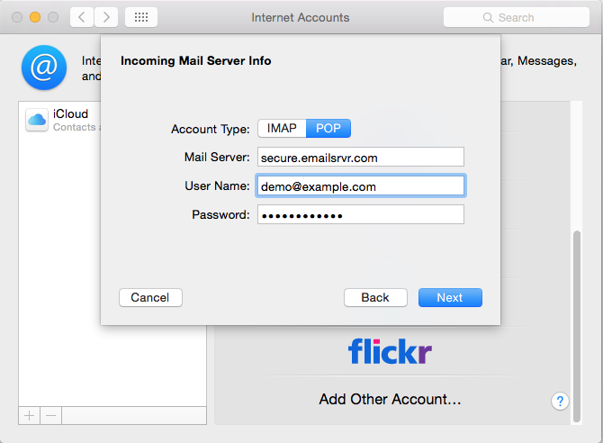
- Click "Next".
- You'll see an alert which says "Additional account information required.". Click "Next" once more.
- Within the next dialog titled "Incoming Mail Server Info", ensure the following:
  - "Port": 995
  - "Use SSL": Checked
  - "Authentication": Password
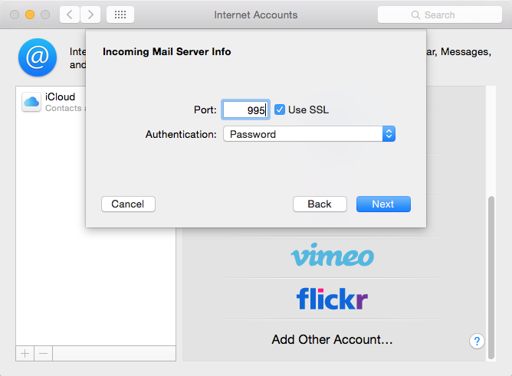
- Click "Next".
- Within the next dialog titled "Outgoing Mail Server Info", ensure the following:
  - "SMTP Server": secure.emailsrvr.com
  - "User Name": Your email address
  - "Password": Your mailbox password
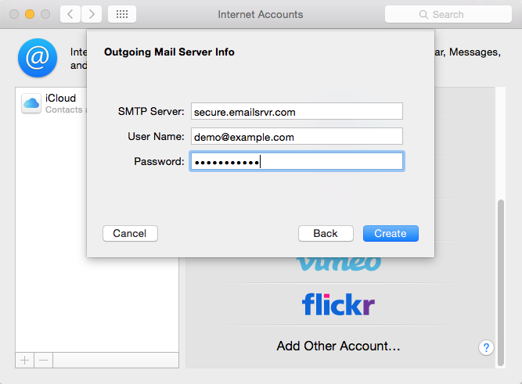
- Click "Create".
- You'll see an alert which says "Additional account information required.". Click "Next" once more.
- Within the next dialog titled "Outgoing Mail Server Info", ensure the following:
  - "Port": 465
  - "Use SSL": Checked
  - "Authentication": Password
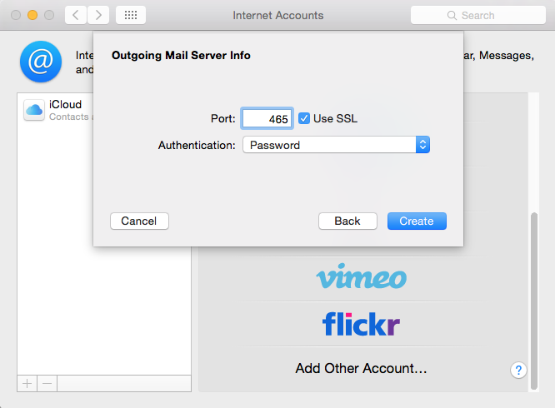
- Click "Create".
- Close the "System Preferences".
- Finally, launch Mail. Your email should begin downloading shortly.

