Android: (IMAP)
This is a setup guide that will assist you in setting up your Android mobile and tablet devices using IMAP.
- Look for "Email" application icon within your Applications. If you cannot find it search for it in your device.
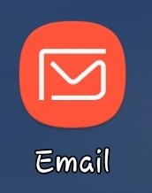
- Click on it and select "ADD NEW ACCOUNT"
- In the wizard provided enter your email address and password. Once you do click on “SIGN IN” at the right bottom corner:
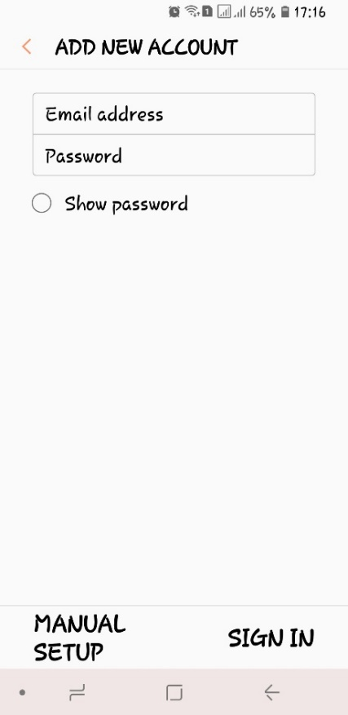
Your email app should automatically find our email server settings in the Internet and if you have any messages on the server they will be all downloaded and synchronized.
If you need any help, please contact:
E-mail: helpdesk@gtt.tools
Skype: helpdesk@gtt.tools

